MO SIEWCHARRAN FUND – GUIDELINES FOR APPLICANTS

About the Mo Siewcharran Fund
Mo Siewcharran, a former Director of Marketing and Communications at Nielsen Books, died suddenly in June 2017. Mo had worked at Nielsen for over 16 years and before that had worked for Hamlyn, Penguin and Haynes. Mo’s husband, John Seaton, launched a Memorial Fund to encourage young people from under-represented backgrounds to pursue a career in the Arts. Mo was passionate about both theatre and publishing and felt strongly about supporting people from the global majority. The intention of the Fund is to help transform lives and inspire young Black, Asian and ethnically diverse candidates who will become part of Mo’s legacy. Read here about the impact of the Fund.

About Creative Access
Founded in 2012, Creative Access is the UK's leading diversity, equity and inclusion social enterprise. We combine practical career access and support interventions that help people from historically under-represented groups to thrive, with progressive recruitment, training and consultancy for employers. Our mission is to see a day when the UK’s creative economy will truly reflect and represent society. Since it was founded in 2012, Creative Access has had an unrivalled impact on changing the face and culture of the creative industries.

Internships
The process of recruiting candidates for the traineeship will be undertaken by Creative Access. It takes 6 – 8 weeks and includes the following:
- Writing up the role as an advert for the Creative Access Opportunities Board
- Marketing every traineeship via our website, candidate database and network of partner orgnisations and education institutions
- Sifting through all applications, creating a long-list of the best-suited candidates and supporting candidates with CV preparation and interview tips
- Liaising with candidates re interview times and tasks on behalf of the partner company
- Supporting unsuccessful candidates with other applications

Successful interns will join the Creative Access Springboard programme, which includes:
- Induction day: These take place at ITV Studios in London for a group of new starters. The day aims to develop core soft skills through personal branding and networking sessions
- Line manager training: 90-minute workshop for the line manager of successful trainee
- Buddies and mentors: We assign each trainee to a peer support group
- Masterclasses: Our monthly evening masterclasses are hosted by some of the UK’s most prestigious organisations (in person and via zoom). These allow candidates to hear from role models, learn about other creative sectors, and provide networking opportunities
- Pastoral support: We provide ongoing support for our trainees so they can discuss any issues or ad-hoc challenges with a member of the CA team
- Mental health and wellbeing: We run regular sessions with a clinical psychologist to ensure trainees feel supported and able to work to the best of their abilities. This includes support with embracing neurodivergence
- Development: Once an individual has completed their traineeship, they can join our Development programme, which provides ongoing career support, mentorship and training

Obligations of participating companies
- To commit to taking on a trainee for a 6-month period
- To provide a line manager and a mentor for the intern
- To allow the trainee to attend a full day induction in London
- To encourage them to attend masterclasses (monthly from 6 – 8pm)
- To provide a contract to the trainee
- To be responsible for paying the trainee directly
- To pay the balance of the trainee’s salary / training allowance (over and above the Fund’s contribution) so it meets at least National Living Wage / London Living Wage
- To contribute £575 to Creative Access to support the trainee’s participation in Springboard (this represents a % discount off standard fees)
- Complete a feedback form at the end of the placement

Obligations of the Mo Siewcharran Fund
- The Fund will allocate 50% of the cost of the intern’s Training bursary based on National or London Living Wage (as appropriate) for 6-months (pro-rated for part-time roles)
- The Fund will also cover all costs relating to the recruitment the candidates

Assessment criteria
We will award applications that offer an enriching traineeship experience, where the individual can make a meaningful contribution to the company and its creative outputs. Beyond their line manager and mentor, the individual should have exposure to various team members.
We are looking to award companies based around the UK and welcome both existing and new partners to Creative Access. Please mention if you’ve retained former trainees recruited via Creative Access and/or have considered the ongoing legacy of this traineeship.

Notes for applicants
- Only companies with less than £15 million turnover will be considered for subsidies
- If you are not successful in your first application, you may submit a second application in the next round. You cannot make more than two consecutive applications
- If you have been awarded a grant by the Fund, you may not reapply for 2 years after your intern has completed their traineeship Assessment criteria

Training bursaries and wage contributions
The grant awards are calculated based on all participating organisations issuing Training contracts to their trainees. The HMRC provides guidance here that defines what constitutes a Training contract. These are not compulsory, and you can choose to issue your intern with a regular fixed term contract, but there are several advantages to you using one:
- When we run recruitment using Positive Action we operate in accordance with the Equalities Act, so internships must be training roles (and not jobs)
- Training contracts also mean that you don’t need to pay Employer’s National Insurance and the intern themselves doesn’t pay tax

Below are the figures below based on both National Living and London Living Wage for a 35 week, based on a 6-month internship, including the equivalent training bursary and the amount contributed by the Fund in the event of a successful application. We have given examples of full-time, 4 day and 3 day per week training bursaries below:

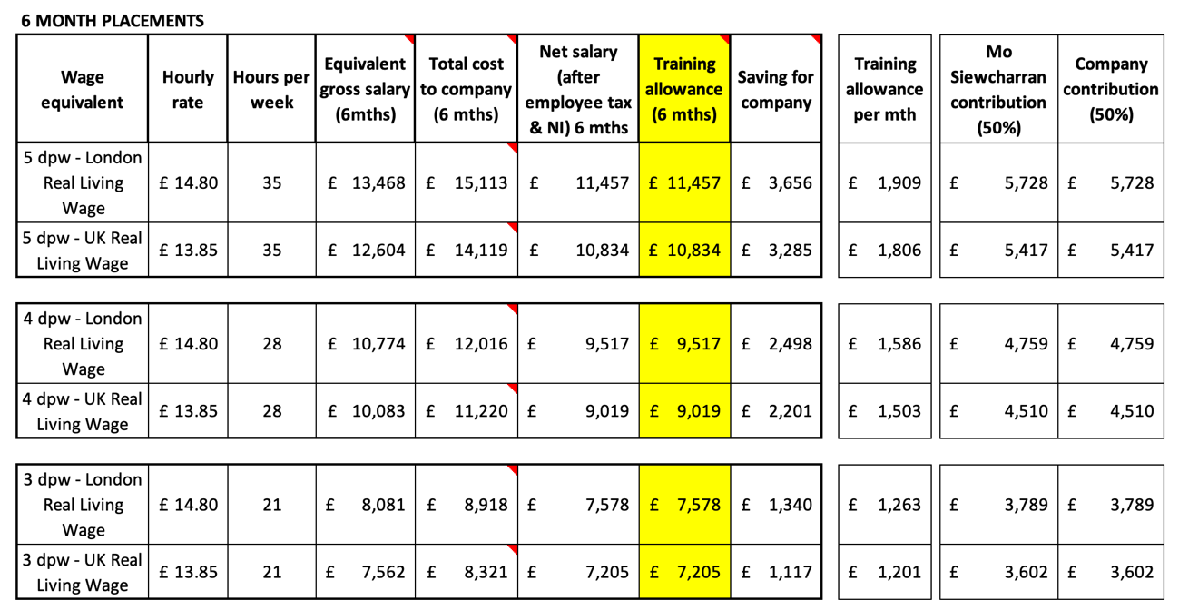

Application deadlines

Round 1
- Deadline for applications: 12 noon, Thursday 27 November 2025
- Companies will be informed: Monday 15 December 2025
- Internships must commence by: 2 April 2026

Round 2
- Deadline for applications: 12 noon, Thursday 25 June 2026
- Companies will be informed by: Monday 13 July 2026
- Internships must commence by: 1 November 2026

APPLICATION FORM – MO SIEWCHARRAN FUND

Company information

Organisation name |  | How did you hear about the Fund?
Recruitment contact |  | Job title
Contact telephone |  | Email
Number of staff |  | Annual turnover

Role details

Start date |  | End date
Duration |  | Location
Line manager name |  | Email
Placement / role title |  | Hours (FT/PT)

About your organisation
Please outline your organisation, including your flagship output:

Placement proposal
Please write a brief outline of the placement you are proposing. Note that the Fund only awards grants to traineeships and not roles which are deemed to be jobs.

Role information

Description of role
Key activities of trainee
What will the trainee learn during the placement | We are not expecting a full training plan at this stage - but an indication of the commitment to developing the trainee in a workplace setting
Line manager | What is the name / title of the trainee’s proposed line manager
Useful knowledge & experience | Please note that as this is a traineeship, we expect this to be general, with no substantial skills or experience required
Academic requirements | We advise that you keep this broad to be as inclusive as possible

Please outline why you are seeking funding and why taking this targeted recruitment approach (focusing on those from Black, Asian and ethnically diverse communities) is necessary:

Please complete this form and send to: recruit@creativeaccess.org.uk

